FOR IMMEDIATE RELEASE
JULY 20, 2018

PAX HUMANA RELEASES “COME ON” FROM NEW EP

THIRD ALBUM “REVOLUTION” ANNOUNCES REBRANDED SOLO ACT

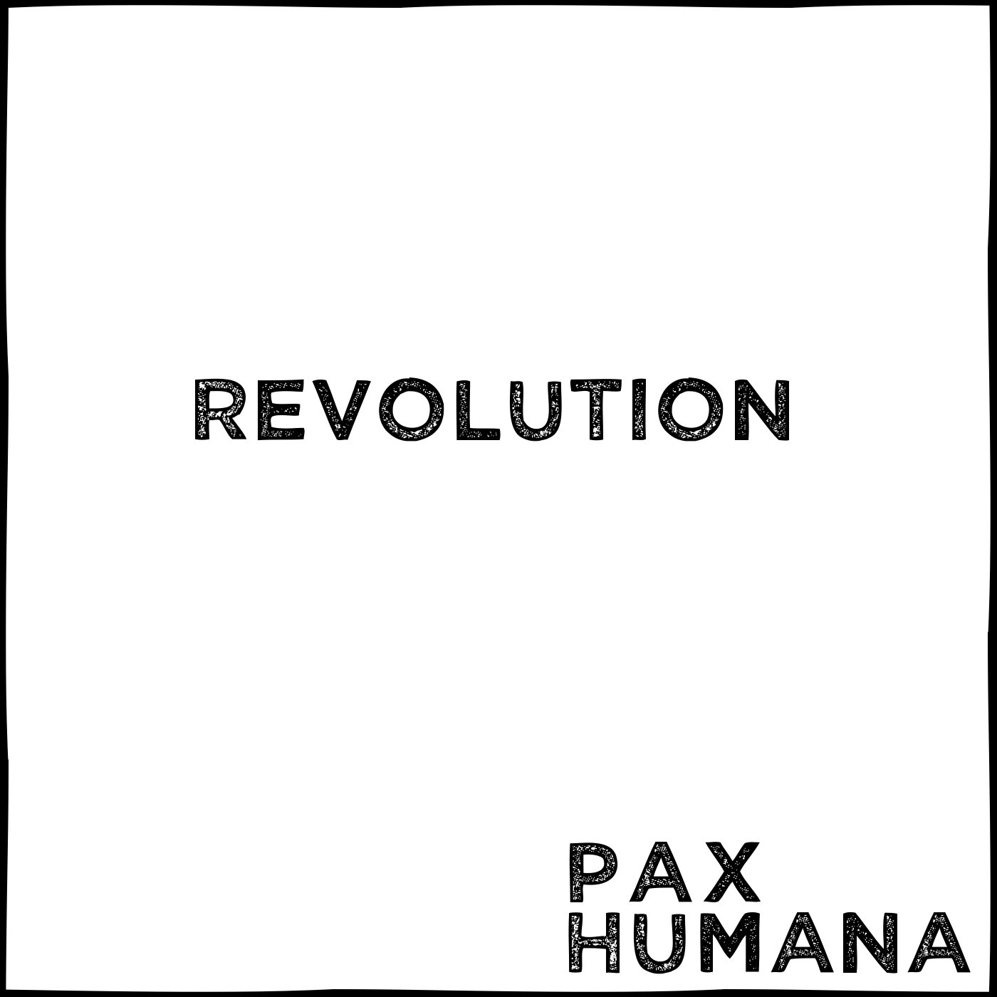

New York City based artist PAX HUMANA has announced the released of his new EP, “Revolution”. The first single will be released Friday, July 20th in anticipation of the album’s August 3rd release. The album includes the seductive single “Come On”. “Come On” will be initially available on Soundcloud and Bandcamp and later on all digital retailers on August 3rd as part of “Revolution”. On July 27th, a second single from the EP is slated for release.

Pax Humana is Brian Lindgren - a classical violist turned electronic music composer. His diverse credits span from recording under Warp Records (for “Central Market”, Tyondai Braxton) to collaborating with hip-hop legend, RA The Rugged Man (Tom Thum on “Legends Never Die”).

“Revolution” marks his first release of 2018 and the first “Pax Humana” release in four years. Following a successful 2014 -2015 NYC run that included their second studio album and packed performances at Slake, Webster Hall and Verboten, the former duo, Pax Humana (Brian Lindgren and Samir Zarif), pursued separate artistic endeavors. Deciding that the mission imbued in the name “Pax Humana” had not reached its completion, he once again raised the banner of Pax Humana, this time as the name for his solo project.

For more information, please visit: www.brianlindgren.com, www.facebook.com/paxhumanamusic, paxhumana.bandcamp.com, www.instagram.com/paxhumanamusic, or www.soundcloud.com/paxhumanamusic

REVOLUTION
- Come On
- Red Light (PH Remix)
- Prophecy
- Cybernetic Fantasy
- No More Questions
- Starfal

